what is a port? like 8000 or 3000 or 5432 in localhost:8000 ?

In computing, a port is a communication endpoint used to distinguish different services or applications running on the same device (like your computer or a server).

💡 Breakdown:
- When you access something like localhost:8000, you're connecting to:
  - localhost: your own computer (loopback network address 127.0.0.1)
  - 8000: the port number which identifies a specific application/service.

🔌 Analogy:
Think of your computer as an apartment building, and each port as a specific apartment:
- The building address is localhost.
- The apartment number is 8000, 3000, 5432, etc.
- So localhost:3000 means you're knocking on apartment 3000 in your own computer to talk to the service running there.

🧠 Why Different Ports?
Multiple services can run on the same machine without interfering:
- localhost:3000 → a React frontend
- localhost:8000 → a FastAPI backend
- localhost:5432 → PostgreSQL database
Each listens on a different port, like each person having their own room.

🎯 Common Port Examples:
Port | Common Use
80 | HTTP (web)
443 | HTTPS (secure web)
22 | SSH (remote login)
3306 | MySQL database
5432 | PostgreSQL database
3000 | Often used by Node.js/React apps
8000 | Often used by development servers like Django or FastAPI

explain more technically, explain it like you are explaining it to a junior network engineer

🔹 What is a Port?
A port is a 16-bit number (range: 0–65535) used in TCP/IP networking to identify specific processes or services on a host.
In short:
A port number, combined with an IP address and protocol (TCP/UDP), forms a socket, which uniquely identifies a network communication endpoint.

🔹 Why Ports Exist
When a packet arrives at a machine (via an IP address), the port number tells the OS which application or service should handle that packet.
Without port numbers, the OS wouldn't know whether to pass the packet to the web server, the database, or an SSH daemon.

🔹 Ports are part of the Transport Layer
Ports live in the Transport Layer (Layer 4) of the OSI model.
Two main transport layer protocols use ports:
- TCP (Transmission Control Protocol) – reliable, connection-oriented
- UDP (User Datagram Protocol) – connectionless, faster but less reliable
A TCP/UDP packet has both:
- a source port
- a destination port
Together with the source/destination IPs, they define a unique 4-tuple:
scss
CopyEdit
(Source IP, Source Port, Destination IP, Destination Port)
Example:
scss
CopyEdit
(192.168.1.10, 50432, 172.217.0.46, 443)
This means: a local app (on port 50432) is connecting to Google (on port 443).

🔹 Port Ranges
Range | Purpose
0 – 1023 | Well-known ports (privileged)
1024 – 49151 | Registered ports
49152 – 65535 | Ephemeral ports (dynamic)
Example:
- 80 = HTTP
- 443 = HTTPS
- 5432 = PostgreSQL
- 22 = SSH
Ephemeral ports are automatically assigned to client-side applications making outbound requests.

🔹 Server vs Client Ports
- Servers listen on well-known or registered ports (like 80, 443, 5432).
- Clients use ephemeral ports to initiate connections.
When you run:
bash
CopyEdit
curl http://localhost:8000
- curl opens an ephemeral port (e.g., 53012) and sends a request to:
  - IP: 127.0.0.1
  - Port: 8000 (server-side port)

🔹 How the OS Handles This
The OS uses a port-to-process mapping table (via the socket API) to route incoming traffic to the correct application.
Example:
bash
CopyEdit
netstat -tulnp
Might show:
nginx
CopyEdit
tcp 0 0 127.0.0.1:5432 0.0.0.0:* LISTEN 1245/postgres
tcp 0 0 127.0.0.1:8000 0.0.0.0:* LISTEN 3221/python3
This means:
- Port 5432 is used by the PostgreSQL daemon.
- Port 8000 is used by a local Python development server (e.g., FastAPI or Django).

🔹 Firewalls and Port Access
Ports are often controlled by firewalls:
- You can allow or block ports.
- Only open ports are reachable from external hosts.
For example:
bash
CopyEdit
sudo ufw allow 22/tcp
Allows inbound SSH on port 22.

🔹 Summary: Key Technical Points
- A port number is a 16-bit identifier in the transport layer (0–65535).
- Combined with IP and protocol (TCP/UDP), it forms a socket.
- The destination port in a packet tells the OS which service to deliver it to.
- Well-known ports are standardized for common services.
- Ephemeral ports are dynamically assigned to clients.

differentiate between port address and socket

🔹 1. What is a Port Address?
A port address refers to the numerical identifier (0–65535) assigned to a specific process or service on a host.

📌 Key Points:
- It exists at the Transport Layer (Layer 4).
- It is not enough by itself to establish communication.
- It just identifies which process on a host should receive the data.
Example:
Port 80 is used for HTTP, 5432 for PostgreSQL, etc.

🔹 2. What is a Socket?
A socket is a combination of:
css
CopyEdit
IP address + Port number + Protocol
Or more formally:
ini
CopyEdit
Socket = (IP address, Port number, Transport Protocol)
It represents a complete communication endpoint.
For two-way communication, both endpoints are identified by socket pairs:
Socket pair:
scss
CopyEdit
(Source IP, Source Port, Destination IP, Destination Port)
This 4-tuple is what uniquely identifies each connection on a TCP network.

🧠 In Simple Terms:
Term | Description
Port address | Identifies a service on a host
Socket | Identifies a connection endpoint (host + service + protocol)

🔁 Comparison Table
Aspect | Port Address | Socket
Layer | Transport Layer (Layer 4) | Transport + Network Layer (L4 + L3)
Uniqueness | Unique per host | Unique per connection
Format | Just a number (e.g., 80, 3000) | (IP, Port, Protocol)
Used by | OS to route data to apps | OS to establish/manage network connections
Scope | Identifies a process/service | Identifies a communication endpoint
Example | Port 5432 | (192.168.0.2, 5432, TCP)
Analogy | Apartment number | Apartment + Building address + Delivery method

🔧 Real Example:
Let’s say:
- You are running a web server on your machine at localhost:8000.
- A browser (client) opens a connection.
Your system might look like this:
Side | IP Address | Port | Protocol | Description
Server | 127.0.0.1 | 8000 | TCP | Web server socket
Client | 127.0.0.1 | 53924 | TCP | Browser’s socket (ephemeral port)
So the socket pair is:
scss
CopyEdit
(127.0.0.1, 53924, TCP) → (127.0.0.1, 8000, TCP)

🧠 TL;DR:
- A port address is like the apartment number inside a building.
- A socket is like the full delivery address: apartment + building + postal service.

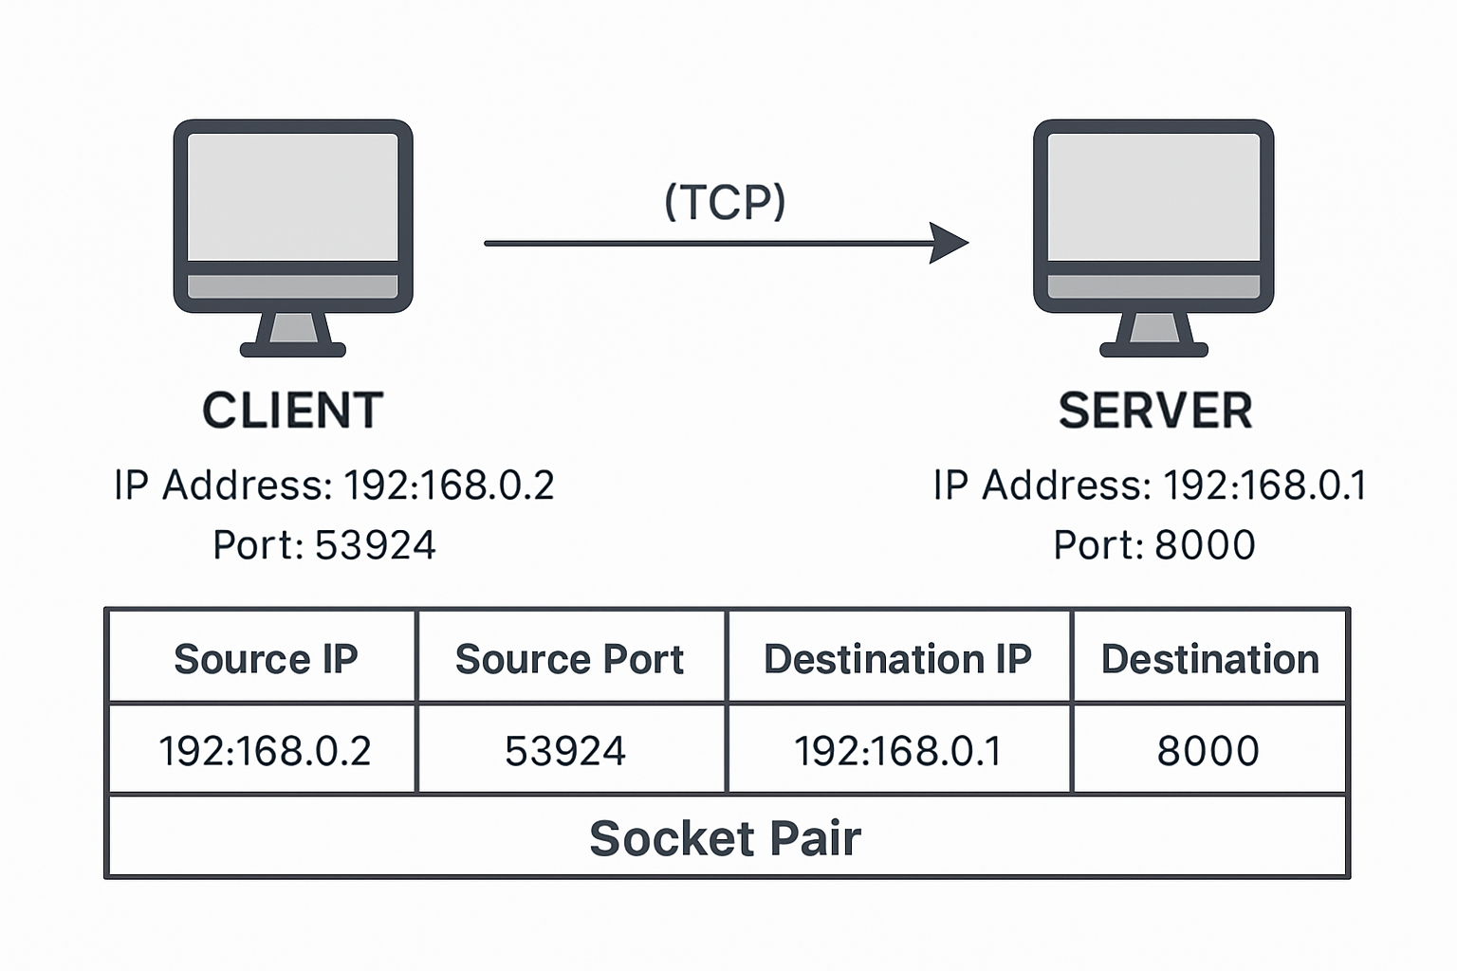
K

a diagram of how packets flow through IP and port layers, or how socket communication works from client to server?

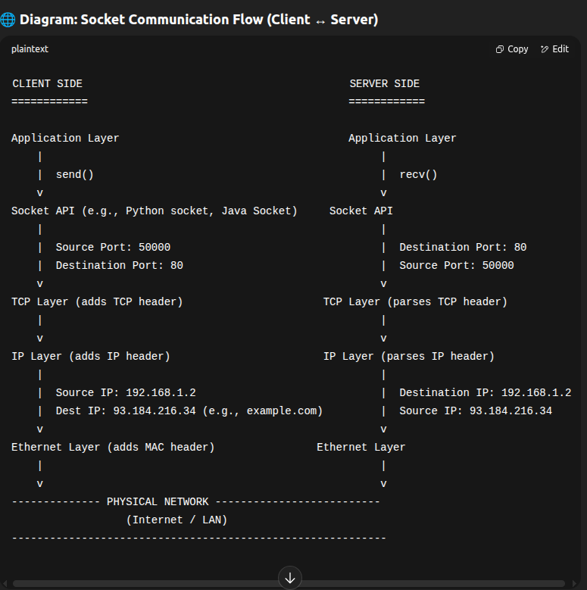
K

🧠 How It Works (Step-by-Step):
- Client creates a socket (e.g., socket(AF_INET, SOCK_STREAM)) and connects to the server IP + port (e.g., 93.184.216.34:80).
- TCP layer on the client wraps the data with a TCP header that includes:
  - Source port (e.g., 50000)
  - Destination port (e.g., 80)
- IP layer adds an IP header:
  - Source IP (e.g., 192.168.1.2)
  - Destination IP (e.g., 93.184.216.34)
- Ethernet layer adds MAC headers and transmits the frame over the network.
- Server receives the frame, strips off MAC, IP, and TCP headers in reverse.
- Server's TCP/IP stack identifies the socket bound to port 80 and passes the payload to the application (e.g., a web server).
- Responses follow the same path in reverse.

💬 Simplified Analogy:
Think of it like sending a letter:
- Port = Apartment number
- IP = Building address
- TCP = Envelope (ensures delivery)
- IP = Postal system
- Ethernet = Mail truck
